**Problem Statement** : To build a QA chatbot either using Retrieval Augmented Generation or using fine tuning but only working with open source models on a specific dataset.

Dataset :

Approach :

1. **Fine Tune QA Model**
   1. Generated Data from PDF on by annotating in the manner of Question,Context,Answer.
   2. Feed Data for Fine Tuning Model .
   3. Model Used :
      1. D
      2. Cx
      3. Cx
2. **Information Retrieval Pipeline** 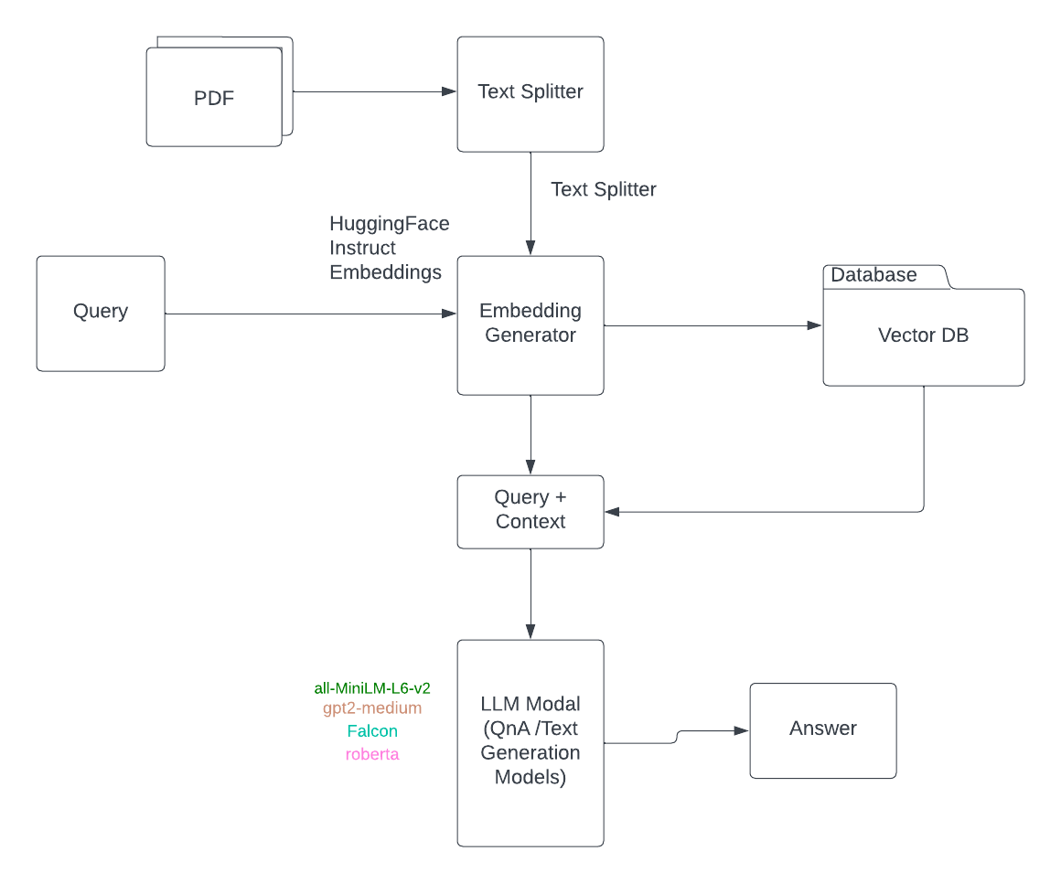
   1. Split PDF Document into smaller chunks
   2. Generate Embedding vectors of the documents.
   3. Store the Embeddings
   4. Generate Embeddings of Query
   5. Compare query with Vector DB for most similar chunk
   6. Use Text Generation over Model to form an answer for the query.
      1. Model Used
         1. Roberta-base-squad2
         2. Roberta-base-squad2-covid

**deepset/roberta-base-squad2**

QUERY :: When did the GARDASIL 9 recommendations change?

----------------------------------------

{'score': 2.9520701900764834e-06, 'start': 287, 'end': 337, 'answer': 'recom- mended for all persons through age 26 years'}

{'score': 8.362870721612126e-05, 'start': 11, 'end': 24, 'answer': 'February 2015'}

{'score': 0.0016043646028265357, 'start': 635, 'end': 652, 'answer': 'December 10, 2014'}

****************************************

QUERY :: What were the past 3 recommendation changes for GARDASIL 9?

----------------------------------------

{'score': 0.007180154789239168, 'start': 602, 'end': 633, 'answer': '3. Food and Drug Administration'}

{'score': 6.158527412480908e-07, 'start': 20, 'end': 24, 'answer': '2015'}

{'score': 3.1480883535550674e-06, 'start': 332, 'end': 333, 'answer': '6'}

****************************************

QUERY :: Is GARDASIL 9 recommended for Adults?

----------------------------------------

{'score': 0.007655641529709101, 'start': 191, 'end': 257, 'answer': 'one of three HPV vaccines that can be used for routine vaccination'}

{'score': 0.004614135250449181, 'start': 590, 'end': 633, 'answer': 'Children and adults aged 9 through 26 years'}

{'score': 0.0001306169288000092, 'start': 744, 'end': 807, 'answer': 'recommendations for children and adults aged 9 through 26 years'}

****************************************

QUERY :: Does the ACIP recommend one dose GARDASIL 9?

----------------------------------------

{'score': 0.01010596752166748, 'start': 102, 'end': 145, 'answer': '9-valent human papillomavirus (HPV) vaccine'}

{'score': 0.09426696598529816, 'start': 438, 'end': 487, 'answer': 'ACIP recommends either 9vHPV or 4vHPV vaccination'}

{'score': 0.15801115334033966, 'start': 373, 'end': 404, 'answer': 'there is no ACIP recommendation'}

**deepset/roberta-base-squad2-covid**

QUERY :: When did the GARDASIL 9 recommendations change?

----------------------------------------

{'score': 3.7271659039106453e-06, 'start': 747, 'end': 835, 'answer': 'Recommendations regarding HPV vaccination during pregnancy or lactation have not changed'}

{'score': 0.00949524249881506, 'start': 11, 'end': 24, 'answer': 'February 2015'}

{'score': 0.1538630723953247, 'start': 635, 'end': 652, 'answer': 'December 10, 2014'}

****************************************

QUERY :: What were the past 3 recommendation changes for GARDASIL 9?

----------------------------------------

{'score': 3.6329885233499226e-07, 'start': 343, 'end': 393, 'answer': 'human papillomavirus 9-valent vaccine, recombinant'}

{'score': 4.305237055746147e-09, 'start': 188, 'end': 257, 'answer': 'as one of three HPV vaccines that can be used for routine vaccination'}

{'score': 3.1828375313125434e-07, 'start': 233, 'end': 237, 'answer': '2016'}

****************************************

QUERY :: Is GARDASIL 9 recommended for Adults?

----------------------------------------

{'score': 0.00026370296836830676, 'start': 185, 'end': 187, 'answer': '.)'}

{'score': 0.0018567913211882114, 'start': 633, 'end': 634, 'answer': '.'}

{'score': 0.0007528535206802189, 'start': 32, 'end': 96, 'answer': 'HPV vaccination is not recommended for all adults aged >26 years'}

****************************************

QUERY :: Does the ACIP recommend one dose GARDASIL 9?

----------------------------------------

{'score': 0.0002106231841025874, 'start': 152, 'end': 187, 'answer': ') (Gardasil 9, Merck and Co., Inc.)'}

{'score': 0.004285336937755346, 'start': 438, 'end': 487, 'answer': 'ACIP recommends either 9vHPV or 4vHPV vaccination'}

{'score': 0.08008167892694473, 'start': 382, 'end': 451, 'answer': 'no ACIP recommendation regard- ing additional vaccination with 9vHPV.'}

****************************************